1. Emotional impact

<https://github.com/KuiKui/Octoboard>

<http://geeksta.net/geeklog/exploring-expressions-emotions-github-commit-messages/>

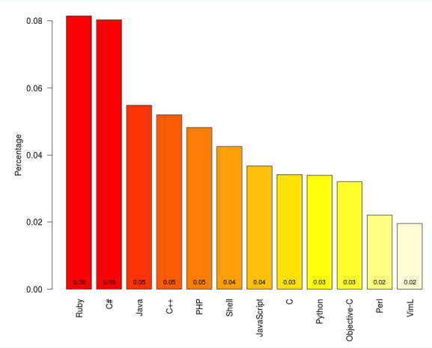

1. Programming language associations

<https://github.com/mjwillson/ProgLangVisualise>

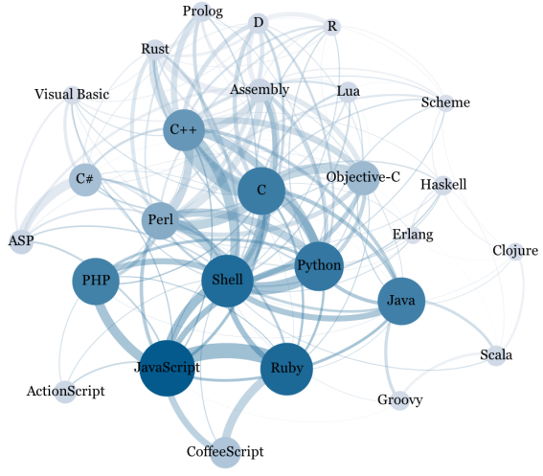

1. Language Popularity

<http://drewconway.com/zia/?p=2892>

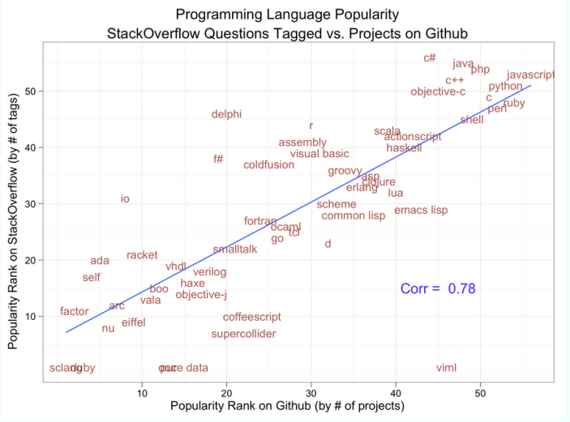

1. Repository activity by language

<http://zoom.it/kCsU>

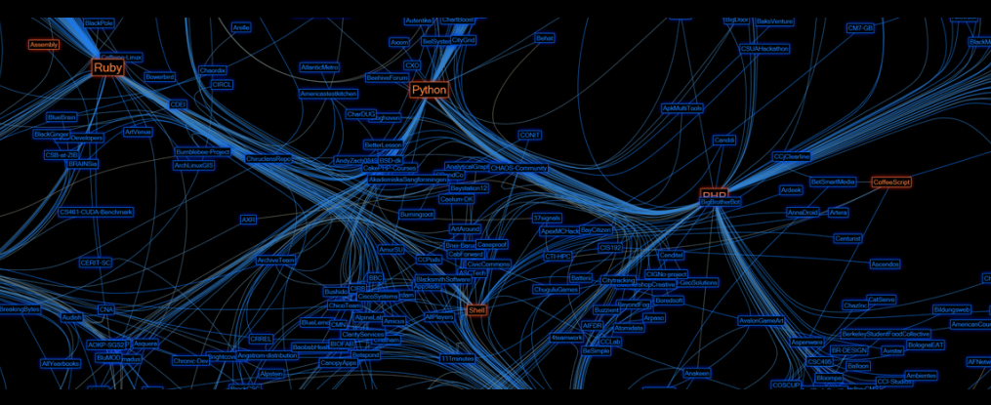

1. GitHub activity by country

<http://geeksta.net/visualizations/github-commit-map/>

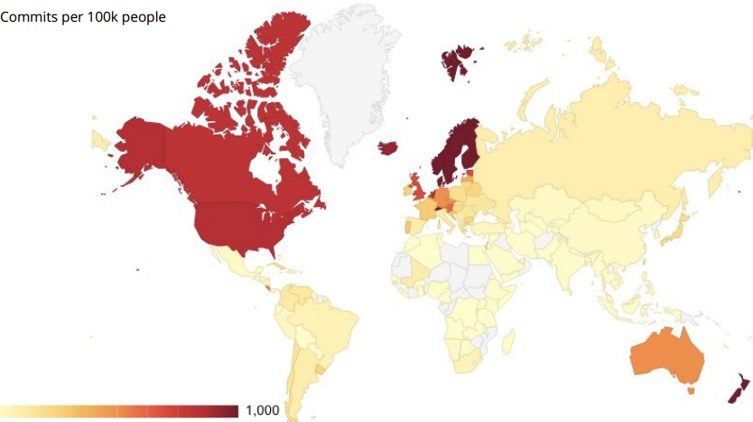

1. Projects using the fork to pull paradigm

<https://gist.github.com/2623537>

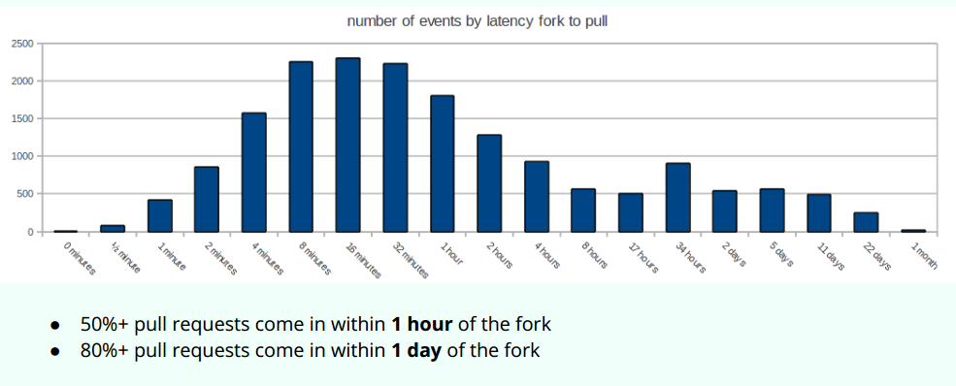

1. What is the "social DNA" of successful open source projects?

<http://www.r-bloggers.com/github-data-analysis/>